Power Design Summary & Physical Build Guidance
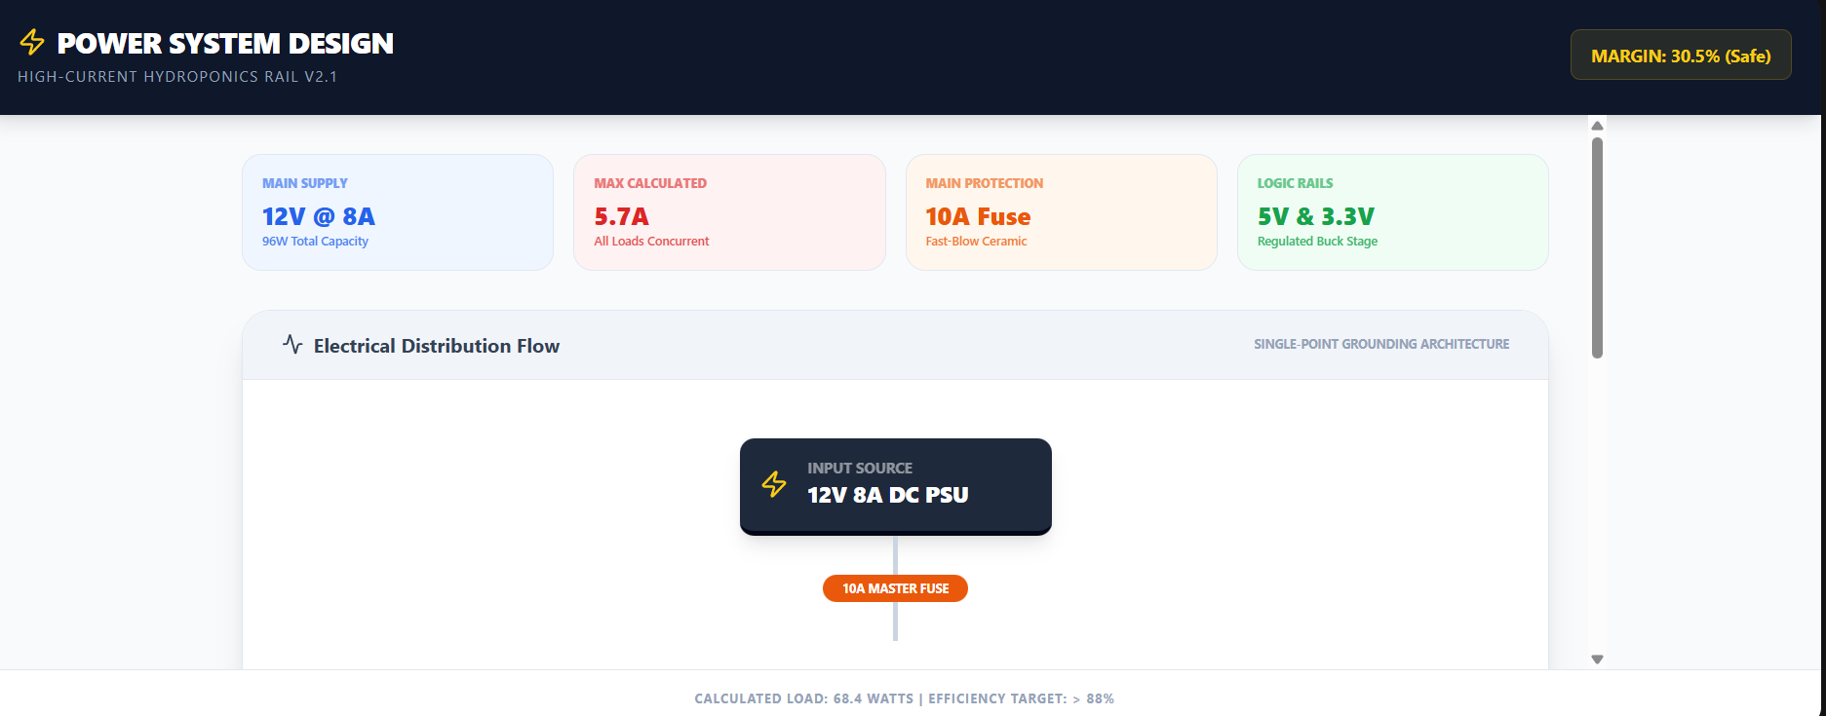
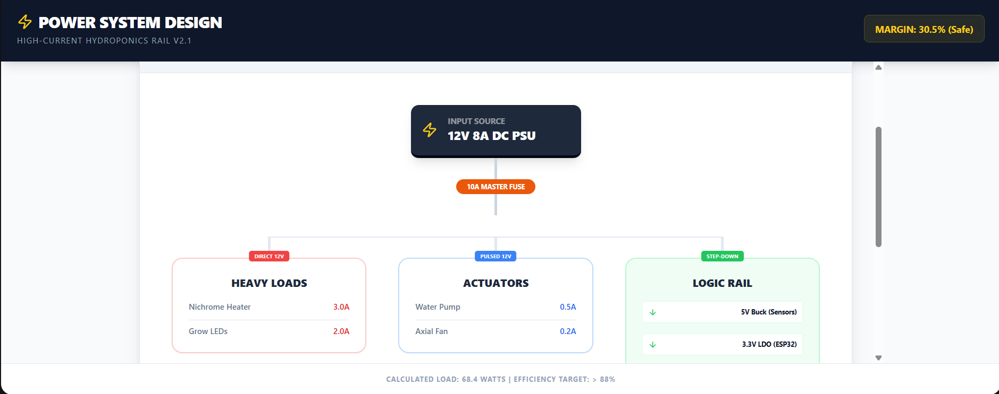
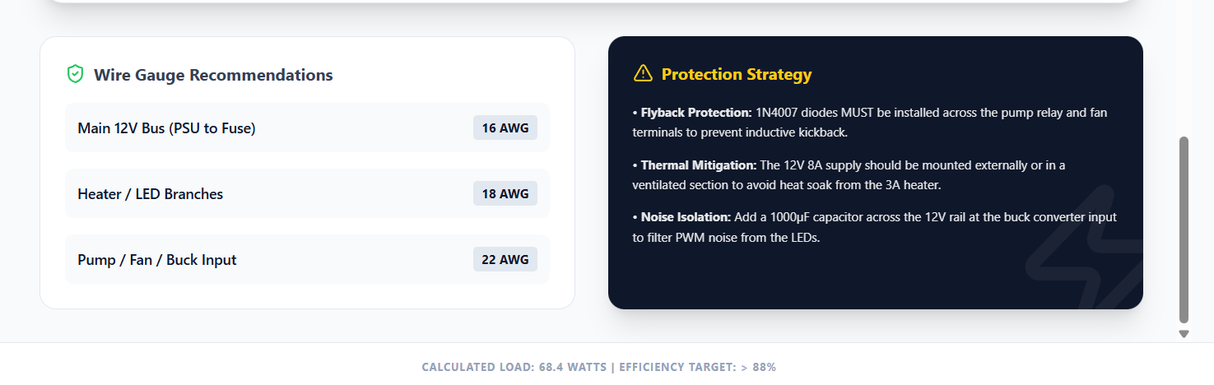

Power Design Summary & Physical Build Guidance
- Supply Upgrade (12V 8A): As we calculated, your peak load is 5.7A. Using an 8A supply ensures that the power unit runs at ~70% capacity during peak load. This prevents the supply from overheating and significantly extends its lifespan.
- The Master Fuse (10A): Use a Fast-Blow Ceramic Fuse. Glass fuses can sometimes arc during high-current failures. The 10A rating allows for the 5.7A load plus the "Inrush Current" (the spike when the LEDs first turn on).
- The Buck Converter Cascade:
  - 12V to 5V: Use a dedicated buck converter (like the LM2596 or MP1584). The 5V rail powers your sensor modules and any logic level shifters.
  - 5V to 3.3V: It is often safer to step down from 5V to 3.3V for the ESP32 using an AMS1117 regulator. This provides a cleaner signal than stepping directly from the noisy 12V line used by the motors.
- Wiring Gauge (Critical for 3A Heater): At 12V, a 3A load over thin wires will cause a significant Voltage Drop. Use 18 AWG wire for the heater and LED runs to ensure they actually receive 12V at the end of the cable.

Circuit Design
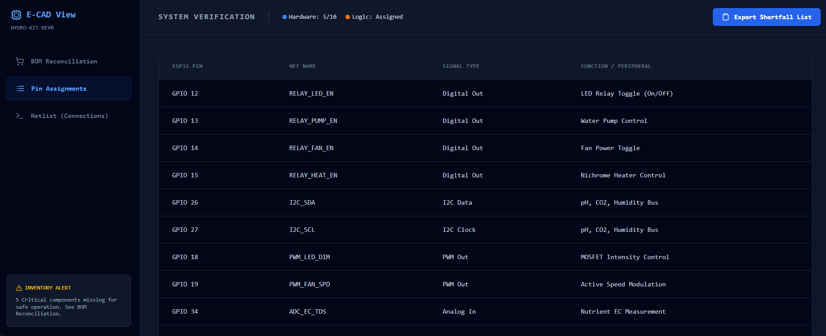
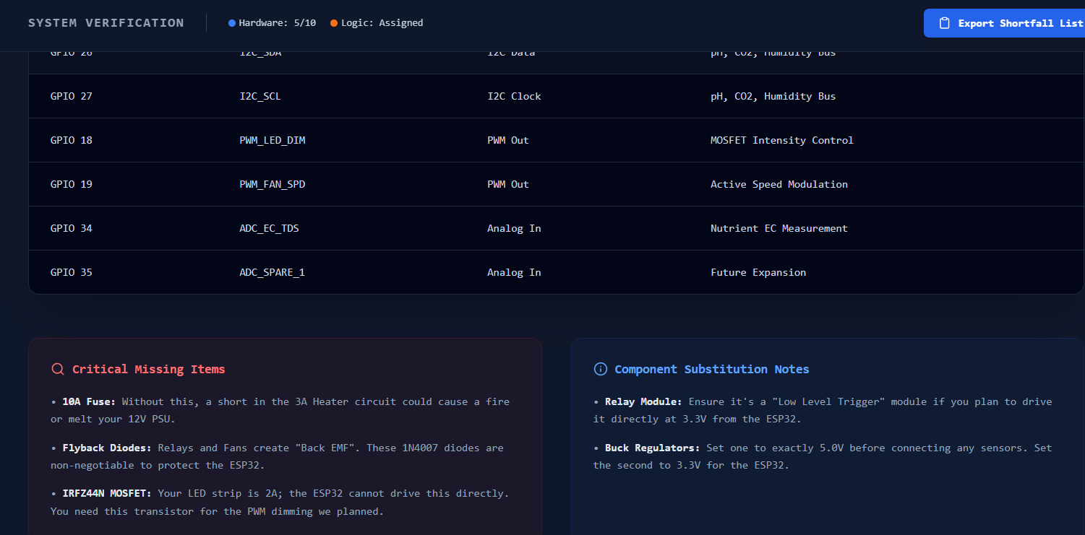
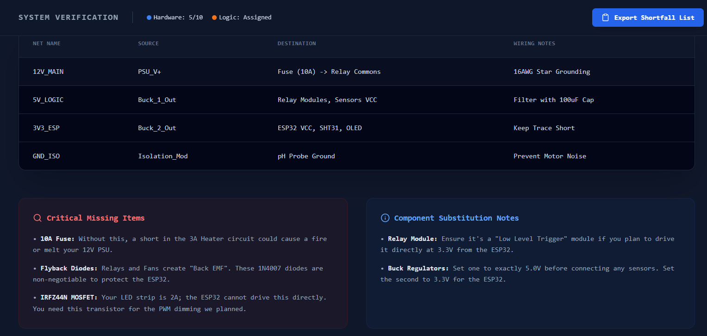 https://gemini.google.com/share/c3627516ff7f
PCB & Protoboard Planning
Layout & Planning Highlights:
Zone Isolation (The "Moat"): I have divided the layout into three distinct physical zones. The High-Power Zone is kept at the edge near the DC Input. The Analog Zone (pH/CO2) is placed as far as possible from the PWM switches to prevent "crosstalk" noise.
Star-Grounding Architecture: This is the most important part of your protoboard build. If your daisy-chain the ground of the 3A Heater to the ESP32, every time the heater turns on, the ground voltage will "jump," likely causing the ESP32 to brown out or crash. Run separate Ground wires from the PSU to each major section.
Connector Selection:
Main Input: Use an XT60 or XT30 connector. They are designed for high-current RC hobby applications and won't melt like standard barrel jacks.
Sensors: GX12 Aviation connectors (3 or 4 pin) are highly recommended. They are waterproof and provide a threaded lock so cables don't pull out of your enclosure.
Wiring Gauge Specs
18AWG: For all paths involving the 3A Heater and 2A LED strip.
22AWG: For everything else (Sensors, ESP32 power, PWM signals).
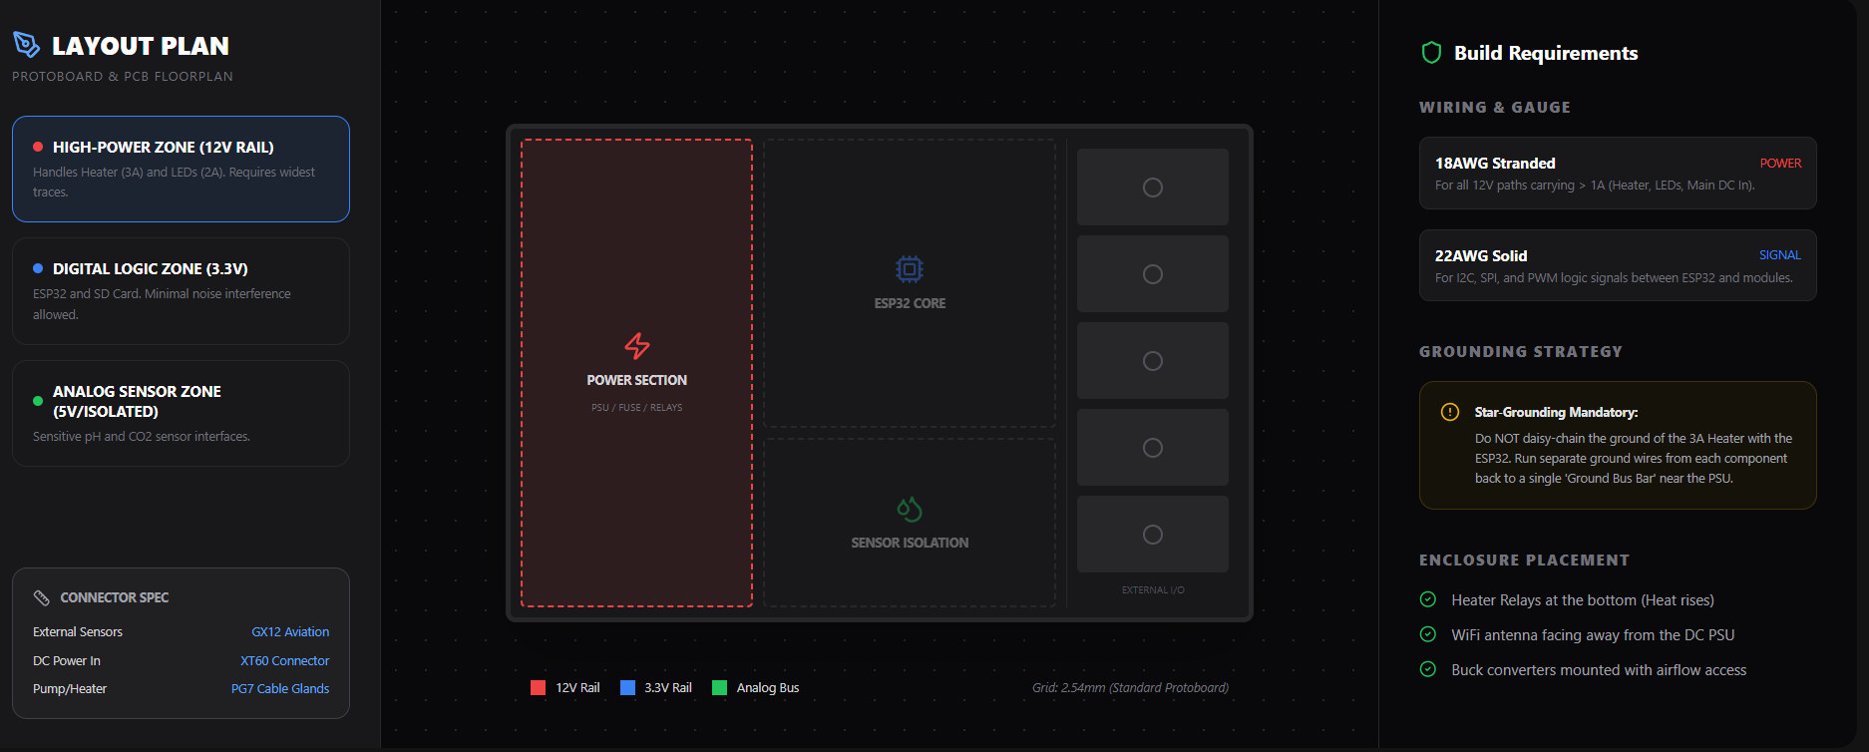
https://gemini.google.com/share/2a631a9d6db7

3D Control Box Visualization and Mechanical Plan.
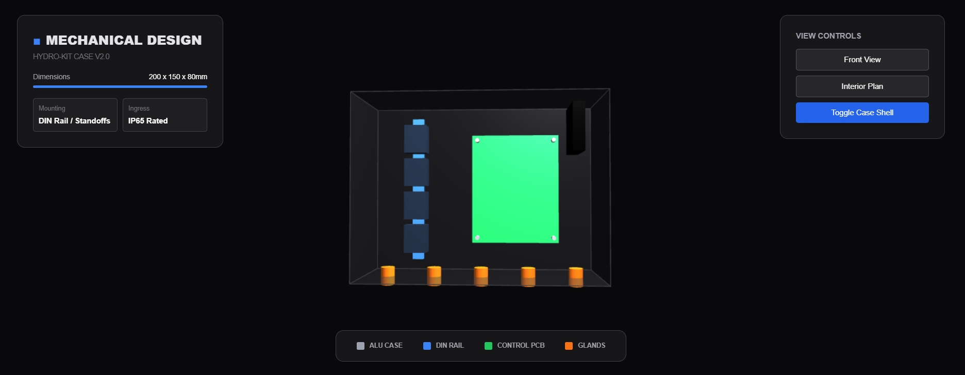
https://gemini.google.com/share/9472062c705d
This 3D model represents the "Gold Standard" for hydroponics control hub.
DIN Rail Mounting: The left side of the box uses a standard 35mm DIN rail. This allows you to "clip in" the relay modules and high-current terminal blocks. It makes replacing a failed relay a 10-second job instead of a soldering nightmare.

Thermal Management:
Intake: A 40mm fan is mounted on the upper right wall to pull fresh air over the ESP32 and Buck regulators.
Exhaust: Drill small "weep holes" or use a breathable vent plug on the bottom left to allow hot air to escape while preventing water ingress.
Cable Glands (The "Octopus"): Use PG7 glands for sensor wires and PG9 glands for the thicker 12V power input. Ensure the glands are mounted on the bottom face of the enclosure so that any condensation on the wires drips off before entering the box.
Labeling System: Inside the lid, I recommend printing a copy of the Pin Assignment table from our schematic_design.jsx and taping it there. Use a heat-shrink labeler (e.g., Dymo) to mark both ends of every wire (e.g., [PUMP_GND], [PH_SDA]).

Design Characteristics for Urban Living
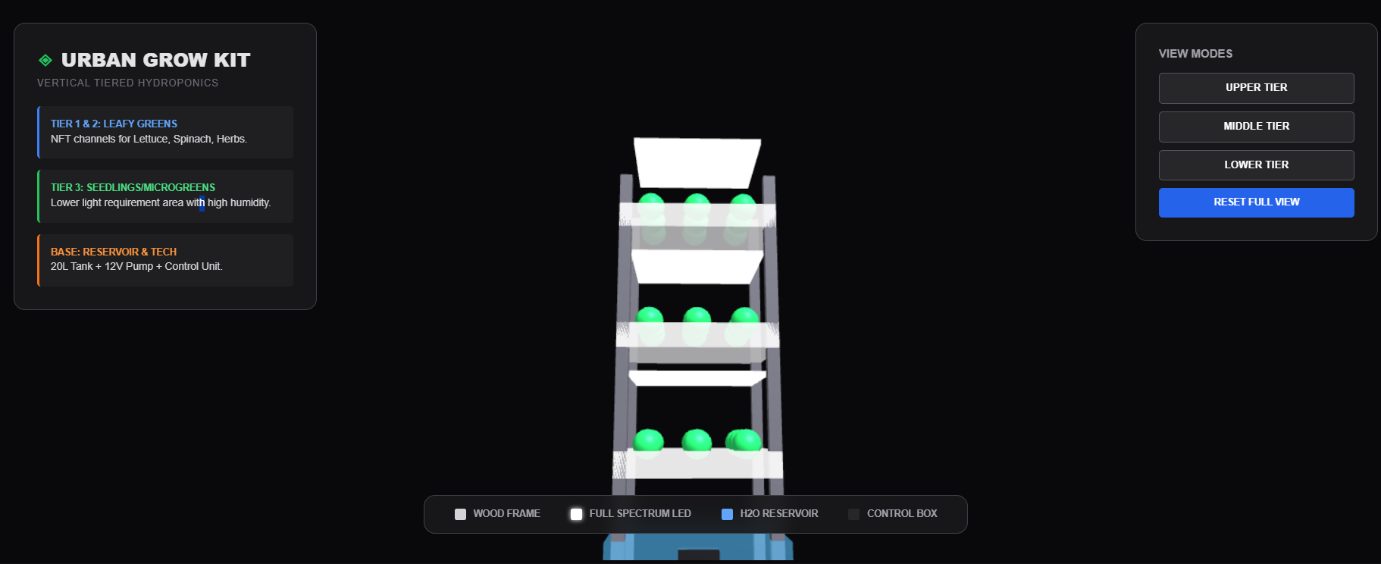
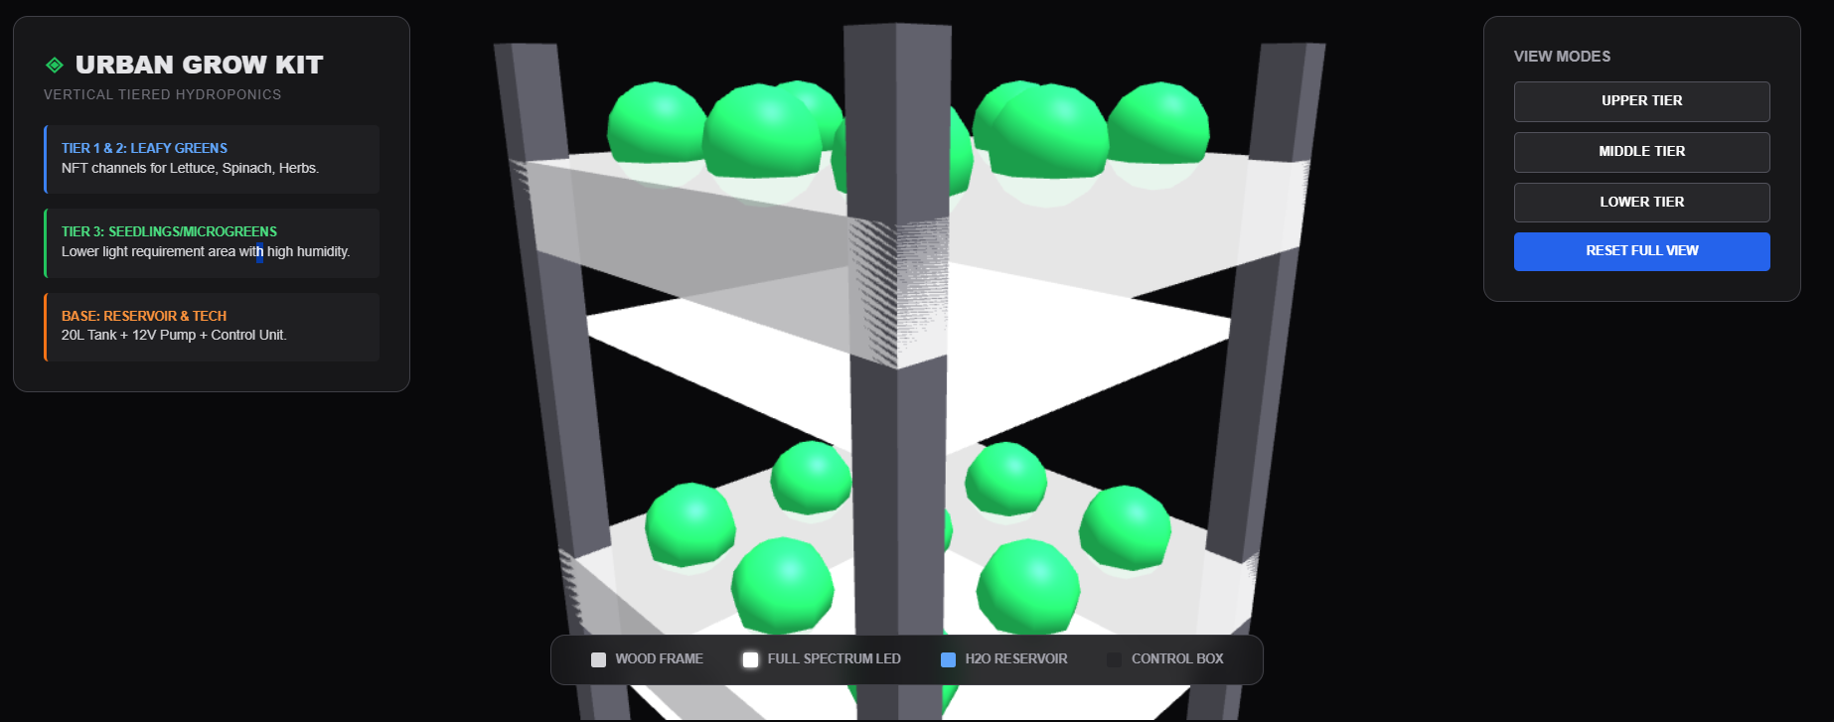
https://gemini.google.com/share/dc06432d79e5
https://gemini.google.com/share/fa0207bceb4e

Vertical Stack (3 Tiers):
Top Tier (Maximum Ventilation): Ideal for fast-growing herbs like Basil and Mint that benefit from air circulation.
Middle Tier: Standard NFT (Nutrient Film Technique) channels for Butterhead or Romaine lettuce.
Bottom Tier: Protected from direct external light; ideal for microgreens or starting seedlings from sponges.
Compact Footprint: At 200cm height and 60cm width, this unit fits comfortably next to a kitchen island or against a balcony wall. The structural pillars are modeled as dark powder-coated aluminum or treated wood to blend with modern home decor.
Integrated Lighting: Each level features an under-shelf Full Spectrum LED panel. Since it's for urban indoor use, these LEDs provide the required 16-hour light cycle regardless of window placement.
Base System:
The 20L Blue Reservoir at the bottom lowers the center of gravity, making the unit stable (crucial for safety).
The Control Box we designed earlier is mounted on the lower right pillar, keeping high-voltage AC-DC conversion far away from the overhead watering lines.
Water Management: The design assumes a "Gravity Return" system—water is pumped from the base to the top tier, then trickles down through the levels via internal piping hidden inside the back pillars.
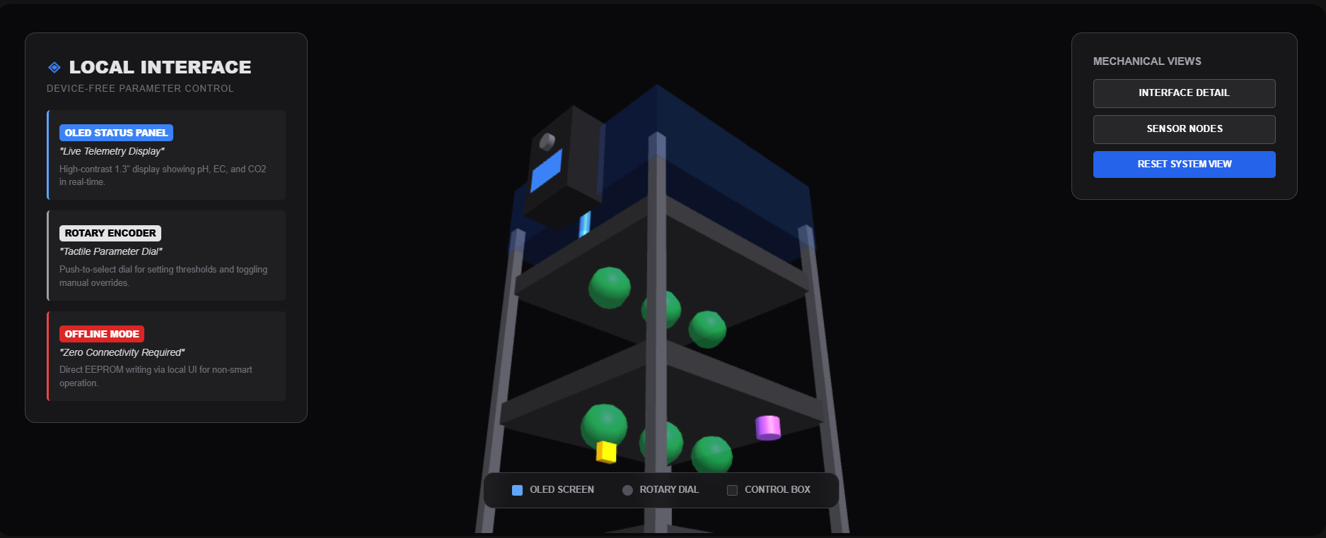
https://gemini.google.com/share/904cf2c4f686

